**Assignment 1(Ex.No 9)**

1. This exercise involves the Auto data set studied in the lab. Make sure that the missing values have been removed from the data.
2. Which of the predictors are quantitative, and which are qualitative?

**Qualitative predictors:**

* Name
* Origin

**Quantitative predictors:**

* mpg
* horsepower
* year
* displacement
* cylinders
* acceleration
* weight

1. What is the range of each quantitative predictor? You can answer this using the range() function.

The Range of,

* Mpg : 9.0 – 46.6
* Cylinders : 3 - 8
* Displacement : 68.0 - 455.0
* Horsepower : 46 - 230
* Weight : 1613 - 5140
* Acceleration : 8.0 - 24.8
* Year : 70 - 82

(c) What is the mean and standard deviation of each quantitative predictor?

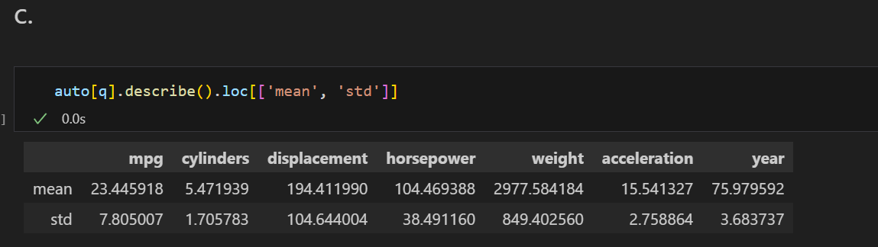

1. Now remove the 10th through 85th observations. What is the range, mean, and standard deviation of each predictor in the subset of the data that remains?

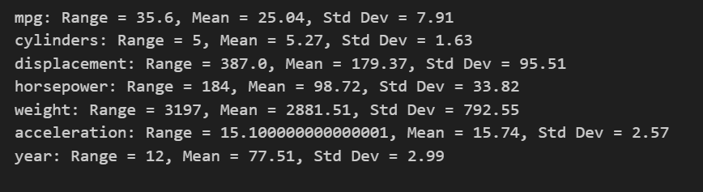

1. Using the full data set, investigate the predictors graphically, using scatterplots or other tools of your choice. Create some plots highlighting the relationships among the predictors. Comment on your findings.

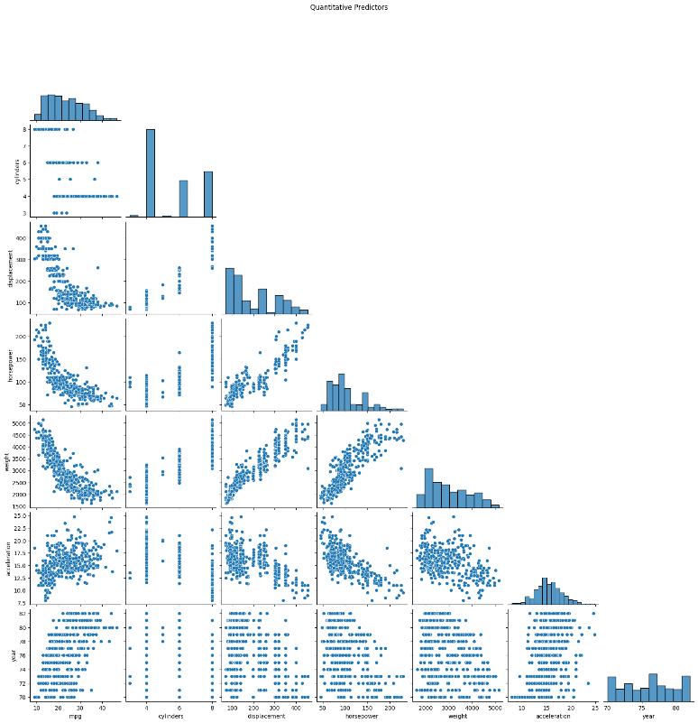

1. Suppose that we wish to predict gas mileage (mpg) on the basis of the other variables. Do your plots suggest that any of the other variables might be useful in predicting mpg? Justify your answer

**Answer:**

Yes, the graphs indicate that certain variables are significant in predicting mpg. There is a clear negative correlation between mpg and factors such as weight, horsepower, and displacement — as these factors increase, mpg tends to decrease. In other words, heavier or more powerful vehicles generally have lower fuel efficiency. Additionally, the 'year' variable shows a mild upward trend with mpg, implying that newer models are typically more fuel-efficient. These variables are valuable for making accurate mpg predictions.

**KAVINPRASATH.S.M**

**1P24CS011**